Purpose
To determine the concentration of ammonium-nitrogen in biomass.

Theory
NH₄-N is found in aqueous-solutions as ammonium-ions and ammonia.
NH₄⁺ $↔$ NH₃ + H⁺
The balance depends on pH and temperature. The higher the temperature and pH-value are, the further the equilibrium is shifted to the side with ammonia $(NH_{3})$.
pKs for $NH_{4}^{+}$ = 9.25 which means with pH > 10 only ammonia ($NH_{3}$, alkalineform) is present in the aqueous-solution.

Principle
One works with a reagent-kit where reagent 1 is very alkaline. Therefore it is mainly ammonia that is present in the sample which is turned into monochloramine using hypochlorite-ions (reagent 2). The monochloramine forms a blue indolphenol-derivate with a substituted phenol. This derivate can be measured photometric.
Apparatus/equipment
Photometer: Merck: Spectroquant
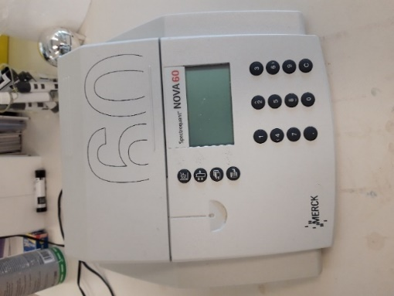
ELMI intelli- mixer (Rotationsmixer)
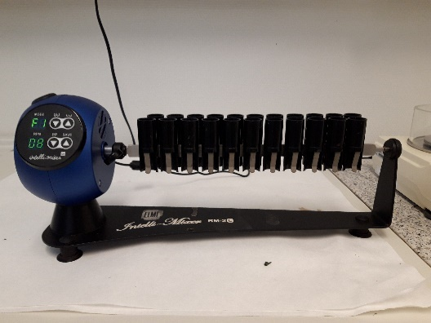
MS 2 Minishaker
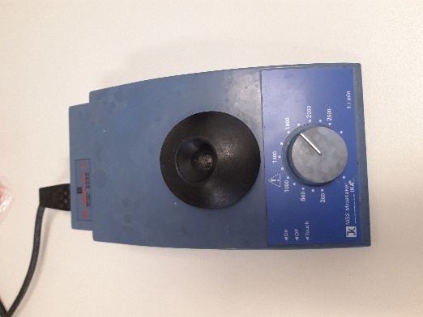
One-time test tube with a lid
One-time plastic pipette with cut off tip
Frisenette Pipette 10 mL, 5 mL and 200 µL
10 mm plastic cuvettes, Cuvetta Std. U.V. Grade, Kartel.L S.p.A, Art. 01939-00

Reagents
Spectroquant Test kit nr 1.00683.001 - It contains: 1 bottle of reagent NH₄ -1 and one can of reagent NH₄ -2 and 2 auto selectors
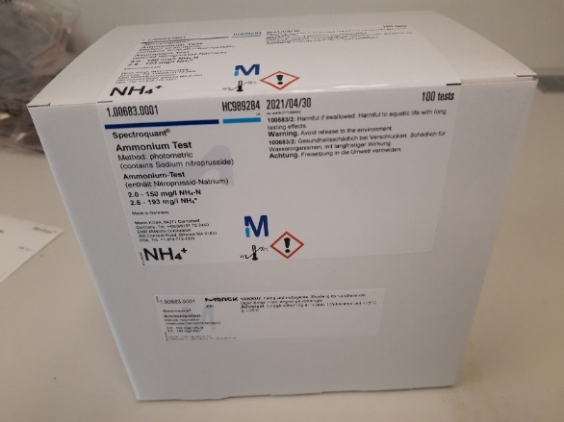
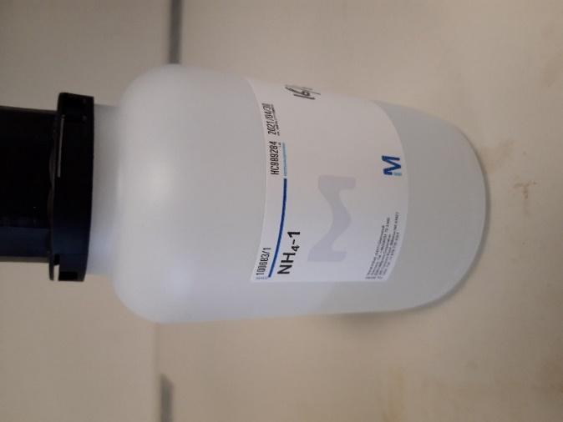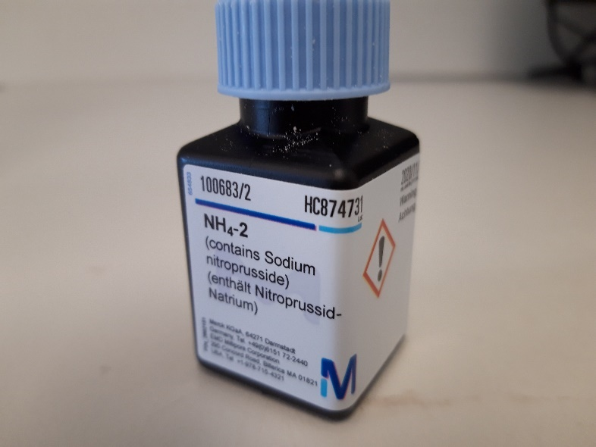
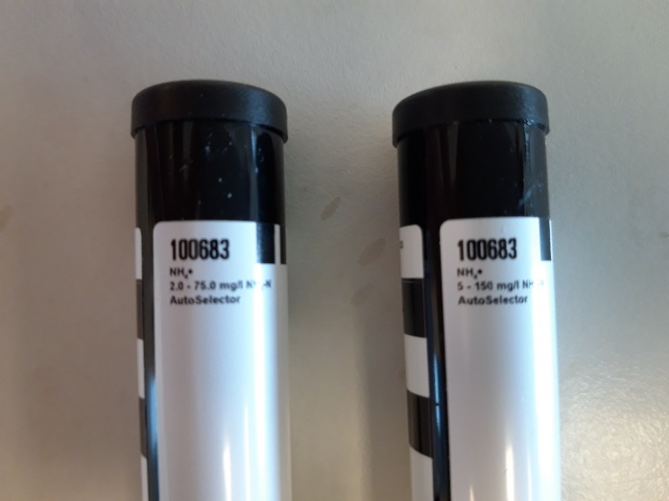 Auto selector: 2,0-75 mg/L and 5,0-150 mg/L
Demineralized water
For the control uses: CombiCheck 70 from spectroquant© (kit nr. 1.14689.0001) R 1 to check the photometrisc measuring system (testreagents, equipment and handling).
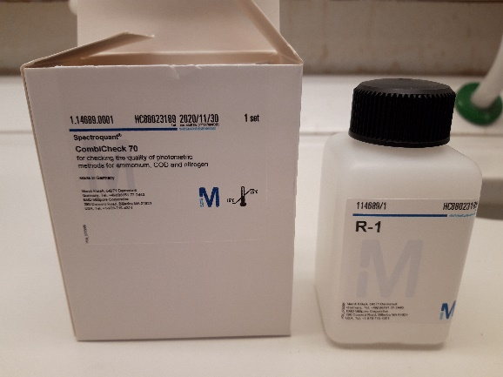

Safety/waste handling
During the analysis one has to put on gloves because reagent 1 is very alkaline and when working with reagent 2 one has to work in the fume hood because some phenol-substances which smells very strongly.
The liquid from the analysis is collected in a bottle and stored until the bottle is full. The bottle shall be kept in the fume hood. The lid shall not be closed tightly. The waste type is H.
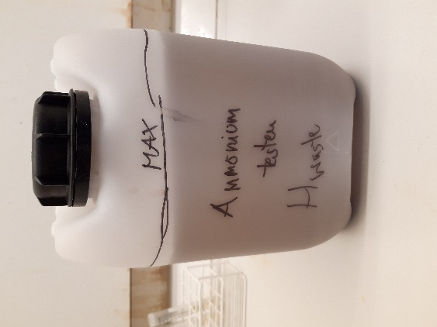
Reagensglas og cuvettes are thrown into the general garbage, dilutions are pured in the sink.

Sample preparation

On average the sample will contain more than 150 mg/L of NH₄⁺, therefore it is necessary to dilute the sample with demineralized water. By diluting the sample, it loses some of its turbidity and thereby it is much easier to measure on the spectrophotometer.

REMEMBER to calibrate the weight before starting.

For the analysis weigh 1 g of sample (the exact weight is noted with 3 digits) with a one-time pipette in a test tube. The sample is then diluted with dem. water 1:10 by adding 9 mL of dem water to the test tube.
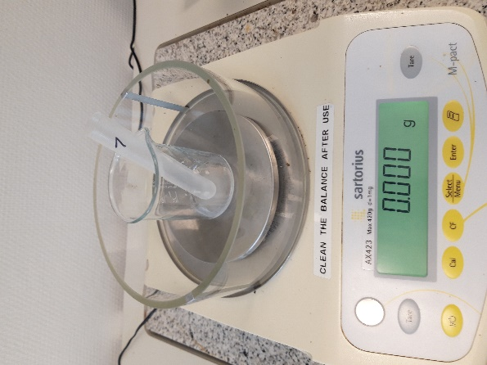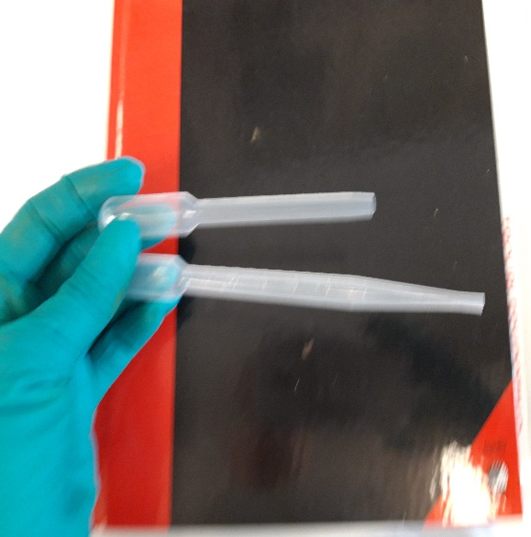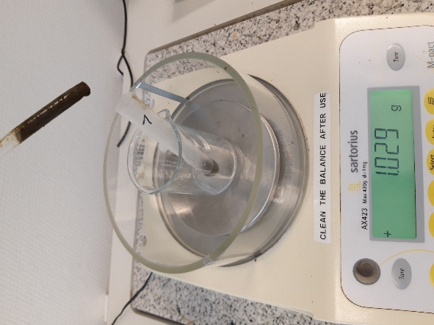

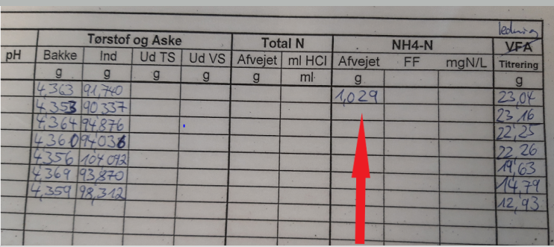

After mixing on the rotation-mixer the solutions is diluted 1:5 meaning 2 mL of the first dilution is added to 8 mL of dem. water in another test tube. The total dilutionfactor is now 50.
Spectroquant Test kit nr 1.00683.001 is used. Since the expected concentration range is around 5-150 mg/L shall one use the matching AutoSelector. The Spectroquant is placed in the fume hood when measuring.
Analyse
While working in the fume hood take 100 $μ$L of the 1:50 dilution and transfer it to 5 mL of reagent 1. For the control transfer 100µL spectroquant© Combi Check 70 into 5 mL of reagent 1. One spoonful of reagent 2 is added and the whole thing is mixed on the minishaker. The sample then has to be left for 15 minutes (the reaction time). Thereafter the sample is transferred to a 10 mm cuvette and the absorption is measured on the Spectroquant NOVA 60.
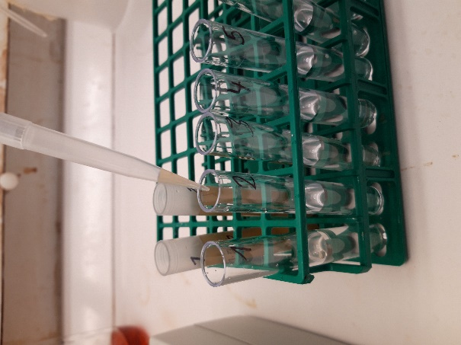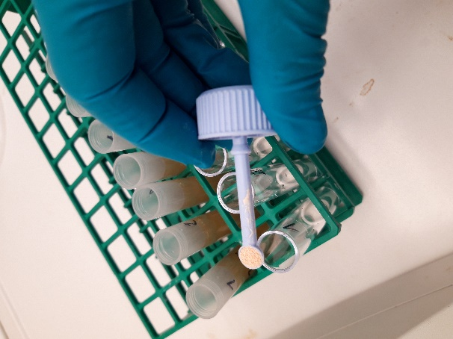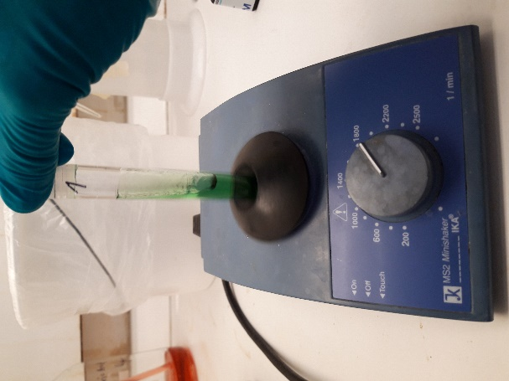
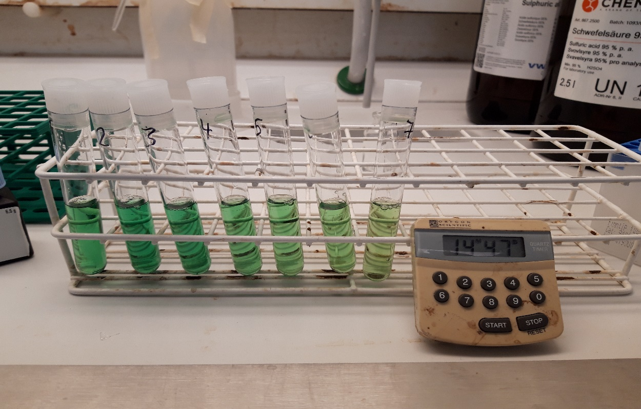
If one is working in the concentration range 2.0-75.0 mg/L NH₄-N 200 $μ$L of the 1:50 dilution has to be transferred to 5 mL reagent 1. Otherwise do as above.
REMEBER to place the AutoSelector so that the markings on the apparatus and the AutoSelector line up.
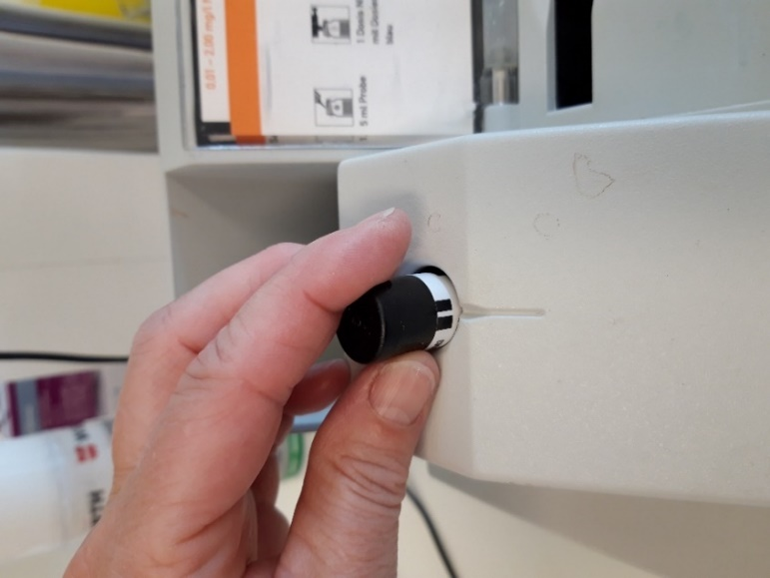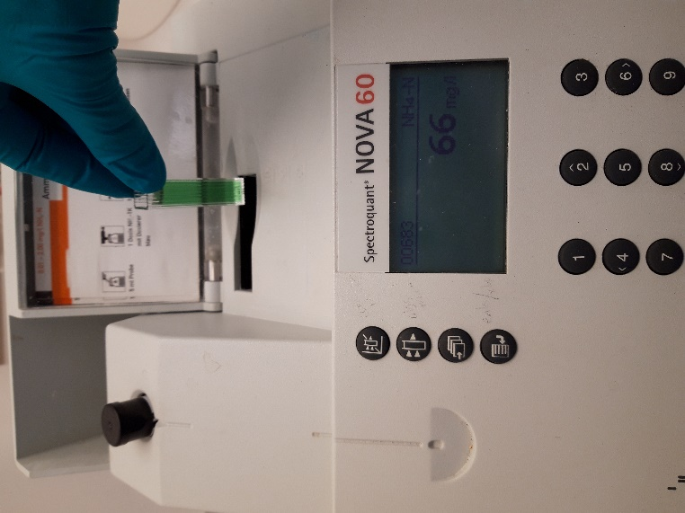
After the end analysis the liquid from the cuvette and the test tube is poured in the garbage-bottle and the cuvette and the test tubes are thrown in the residual waste (large bins).
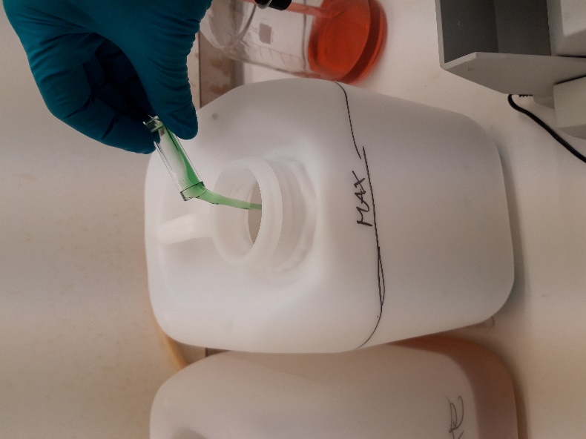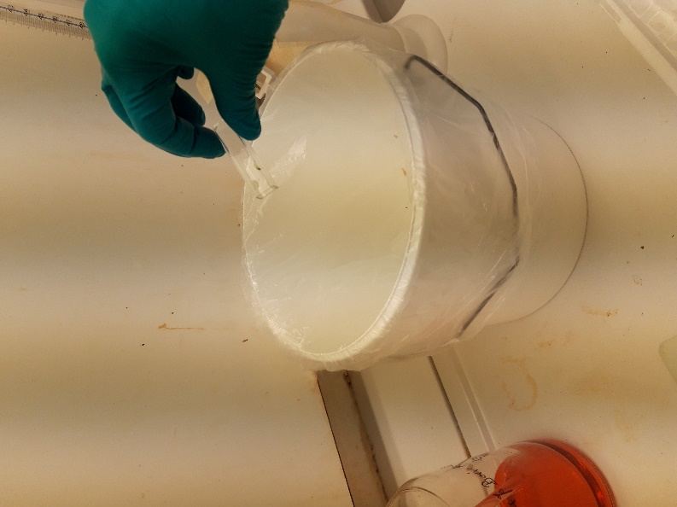
Note the result of the samples on the data sheet. Note the concentration of the control in the control chart and write the number of samples, method… in the logbook.
Standard Preparation
One has to make a standard solution of NH₄Cl in 0.02M boracid (H₃BO₃₎.
NH₄Cl has to dry at $105℃$ for 2 hours and the be cooled down to roomtemperature in ekssikkator before use.
Stock solution is: 3000 mg N/L in 0.02 M H₃BO₃.
Producing the standard: Weigh 11.456 g ± 0.004 g of NH₄Cl and note the exact weight. Transfer the powder to a 1 L volumetricflask. Add approximately 800 mL of dem. water. Add 31 mL of 4% H₃BO₃ and fill to the mark with dem. water.
Calculation: se below
Results
Read the concentration of H₄-N in mg/L. REMEMBER to take the dilutionfactor into count. Calculation below.
Calculation
Calcualtion of NH₄-N concentration in g/L:
$\frac{{prøve}_{afvejet} [g]}{FF*aflæst [\frac{mg}{L}]}$ = $\frac{1 [g]}{x {NH}_{4}-N[\frac{mg}{L}]}$

x NH₄-N [g/L] =( $\frac{1 \left[g\right]*FF*aflæst [\frac{mg}{L}]}{{prøve}_{afvejet }[g]})$ * $\frac{1 [g]}{1000 [mg]}$
Eksempel:
g | NOVA(mg/L)
afvejet | NH4-N | NH4-N (g/L)
1,047 | 40 | 1,91
FF = 50

NH₄-N [g/L] = $(\frac{1 \left[g\right]*50*40 \left[\frac{mg}{L}\right]}{1,047\left[g\right]})$ * $\frac{1 [g]}{1000 [mg]}$= 1,91 g/L

Calculation of Standard:

M_{NH4Cl} = 53,49 g/mol
$$\frac{14,007 g N}{53,49 g NH4Cl}= \frac{3000 mg=3g N}{x g NH4Cl}$$

$$x= \frac{3 g*53,49 g}{14,007 g}=11,456 g NH4Cl$$

One have to weight 11.456 g of NH₄Cl per one liter to get 3000 mg N/L.

Calculation of molarity from solution, if one adds 31 mL of 4% H₃BO₃ to 1000 mL:

C₁* V₁ = C₂* V₂

4% H₃BO₃ * 31 mL = C₂ * 1000 mL

$$C_{2}= \frac{4\%*31 mL}{1000 mL}=0,124 \% H3BO3$$

0,124 % ≙ $\frac{0,124 g}{100 mL}= \frac{1,24 g}{1000 mL}$

M_{H3BO3}= 61,83 g/mol

$$\frac{61,83 g}{mol}= \frac{1,24 g}{x }$$

$$x= \frac{1,24 g*mol}{61,83 g}=0,02 mol$$

The final solution is then containing 0.02M of H₃BO₃.

Safety

Ammonium analusis  2,0-150 mg/L NH4-N | NH₄-2 | Warnings  GHS 07  H302  H412  P273 | ??- affald | One has to work in the fume hood and wear gloves and safety googles.

Hazard and Precautionary:
H302 Farlig ved indtagelse
H412 Skadelig for vandlevende organismer, med langvarige virkninger.

P273 Undgå udledning til miljøet.

